Art Lesson Portfolio
Grade level: 2nd grade Science
Theme: Life cycle
Title: The Wonderful Life Cycle of Butterflies
EXAMPLE!!!!
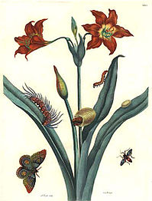
Painting:
For this lesson, I choose this painting by Maria Sibylla Merian. Merian was one of the first naturalist to observe insects directly. She collected a variety of insects to then create detailed drawings. At the time of her drawings, the process of metamorphosis was unknown. Through her time, she documented evidence and described the life cycles of 186 insect species. With collected evidence, Merian would create elaborate drawings to represent the life cycles of these species in their natural habitat. I believe this drawing of the life cycle of a butterfly would portray to my students that they can become creative in their artwork. The students are able to look at this piece of art by Merian, and see the different stages at which the butterfly is at. Students will be able to create their own vision of the 4 stages of the life cycle during this lesson.
TEKS:
Science TEK: §112.13. Science

- (10) Organisms and environments. The student knows that organisms resemble their parents and have structures and processes that help them survive within their environments. The student is expected to: (A) observe, record, and compare how the physical characteristics and behaviors of animals help them meet their basic needs;(B) observe, record, and compare how the physical characteristics of plants help them meet their basic needs such as stems carry water throughout the plant; and (C) investigate and record some of the unique stages that insects such as grasshoppers and butterflies undergo during their life cycle.

Art TEK: §117.108. Art

- (2) Creative expression. The student communicates ideas through original artworks using a variety of media with appropriate skills. The student expresses thoughts and ideas creatively while challenging the imagination, fostering reflective thinking, and developing disciplined effort and progressive problem-solving skills. The student is expected to: (A) express ideas and feelings in personal artworks using a variety of lines, shapes, colors, textures, forms, and space; (B) create compositions using the elements of art and principles of design; and; (C) identify and practice skills necessary for producing drawings, paintings, prints, constructions, and sculpture, including modeled forms, using a variety of materials.
Objective: The student will investigate the unique stages that insects such as butterflies undergo during their life by reading The Amazing Life Cycle of Butterflies, and then create paintings and drawings.
3325 Lesson Cycle Template

Connection to previous learning, life, literature, etc | I will begin by getting my students attention for the lesson by asking, Does anyone know how a butterfly comes about? Does anyone know that there are stages to become a butterfly? What stages did you come about during your lifetime? I will listen to my students about what they know about butterflies and how they form. Then respond with, “Today class, we will be drawing our own portrait about the four-stage life cycle of butterflies. Let’s begin!”
Teaching Point | Today, I want to teach you that there are 4 stages in the life of a butterfly. We will be able to draw a picture of the stages of life as if we were watching a butterfly form. From our drawing by Ms. Merian, we can see that she portrays each stage of a butterfly’s life onto a flower. I will show the piece of artwork created by Merian and explain the four stages she has drawn.
Teach | I will begin my lesson by introducing a book called, “The Amazing Life cycle of Butterflies”, to my students.  After the first stage, I will stop my reading and ask the students, “What stage is the butterfly at?”, “How might you want to create this stage in your own drawing?”  I will continue reading until we get to the second stage and stop to ask my students What stage the butterfly is at, and how can they relate to the current stage of the butterfly.  I will finish the book reading to my students.  “Listen to me as I show you what we are going to be doing.”  I will first get a sheet of construction paper, and a variety of utensils to draw or paint with.  Then, I am going to reflect about the stages that I saw in the book we just read.  Then, I will start to create my own portrait of how a butterfly comes to be.  I will tell my students, “Now, when we are creating our own portrait, I want you to become creative. We do not have to follow the drawing by Merian, but if that is how we see the four stages of a butterfly that is okay.”  When I have created my drawing, I will look back to see if I have the four stages visible to show the entire life cycle of the butterfly.  Once I have finished, we will share our own portraits to the class, and how we creatively portrayed the life cycle of a butterfly.
Active Engagement | Now it’s your turn to try it out!  Students will begin by choosing a piece of construction paper. They can choose from a variety of colors if they want. Then students will decide the type of utensils they choose to create their drawing. Once they have the materials they need, students will begin to reflect the four stages of the life cycle. They will start to draw how they portray each stage of the cycle onto their sheet of construction paper. If students are stuck, they can refer back to the book about the life cycle, ask a neighbor who understands the stages, or I can ask me if they still are struggling. After the students have completed their artwork, we will return to the carpet area.
Link to future learning/Check for understanding | I will make sure my students understood my teaching by asking them, “Who can tell the four stages the butterfly undergoes? “What have we practiced today?”. I want my students to understand not only the four-stage life cycle of the butterfly, but also that we can be creative in our own artwork. It is okay that our drawings do not look others. At this time, I will allow students to share their creative piece of artwork if they choose to do so.
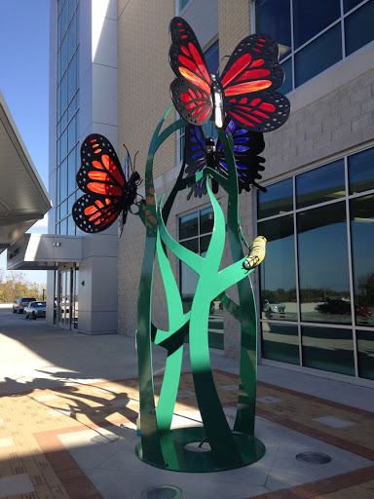
Sculpture:
For this lesson, I chose this sculpture by Michael Mistler. Mistler is a steel construction artist. He creates all types of animal related sculptures no matter what size. Before creating a piece of art, he researches about the given topic. As you see in this sculpture, Mistler shows two of the four stage life cycle of a butterfly. The students will be able to see how others create different versions of butterflies and caterpillars through using a different type of materials.

TEKS:
Science TEK: §112.13. Science

- (10) Organisms and environments. The student knows that organisms resemble their parents and have structures and processes that help them survive within their environments. The student is expected to: (A) observe, record, and compare how the physical characteristics and behaviors of animals help them meet their basic needs;(B) observe, record, and compare how the physical characteristics of plants help them meet their basic needs such as stems carry water throughout the plant; and (C) investigate and record some of the unique stages that insects such as grasshoppers and butterflies undergo during their life cycle.

Art TEK: §117.108. Art

- (2) Creative expression. The student communicates ideas through original artworks using a variety of media with appropriate skills. The student expresses thoughts and ideas creatively while challenging the imagination, fostering reflective thinking, and developing disciplined effort and progressive problem-solving skills. The student is expected to: (A) express ideas and feelings in personal artworks using a variety of lines, shapes, colors, textures, forms, and space; (B) create compositions using the elements of art and principles of design; and; (C) identify and practice skills necessary for producing drawings, paintings, prints, constructions, and sculpture, including modeled forms, using a variety of materials.
Objective: The student will investigate the unique stages that insects such as butterflies undergo during their life style, and use prior knowledge to create constructions, and sculpture using a variety of materials.
3315 Lesson Cycle Template

Connection to previous learning, life, literature, etc | To get my students attention for this lesson, I will start off by asking, “So yesterday, we learned about the four-stage life cycle of a butterfly, and created a drawing. Can anyone tell me the four stages?”. “What happens at these stages?”  I will be listening to my students to see if they can explain the four different stages. Then I will respond with, “Well today, we will be using what we know about the four stages to create our own sculpture!”
Teaching Point | Today, we will be working in our group stations in the art center. We will create paper plate model of the four-stage life cycle of a butterfly. We have a variety of materials that we can use to create each stage of the cycle.
Teach | Listen to me as I show you what we are going to be doing to create our plate.  First, we will be going to get a paper plate from our center, and think about how we can divide the plate into four sections that our stages will be placed at.  Then, I will look at all of the different materials I can use to create each stage. Will I use pom poms to create the larvae and caterpillar? I can use use pipe cleaners to create the antennas. I will how I can create the body of a butterfly using a toilet paper roll, or even uncooked noodles. We can also use construction paper to cut out wings and leaves.  I will explain to the class, “We have all sorts of materials within our center that we can use to create our sculptures of the stages. Let your creativity be shown when we are creating our plates”.  Once I have created my plate, I will check to make sure all four stages are visible, and how we creatively portrayed the life cycle of a butterfly.
Active Engagement | Now it’s your turn to try it out...  Students will begin by getting paper plate from the supply station.  They will also have the option of various materials that they choose to create each stage of the life cycle.  Once students have gathered all of their materials, they will decide where each stage will be shown on their paper. They will then start to create a model of each stage using the materials of their choosing.  When the student has finished the entire life cycle on the plate, they will make sure that each of the four stages is shown.  If the student is stuck and need assistance, they can ask a neighbor, or ask me for some guidance.  When they are all done creating the model, they will return to the carpet area where students are allowed to show the class their creative sculpture.
Link to future learning/Check for understanding | Today we learned that we can all types of materials to create sculptures. We learned that each and every one of you used the materials in your own way to create the four-stage life cycle of a butterfly. We were able to express our creativity through building with classroom materials.

Visiting Artist: Vickie McMillan


I chose Vickie McMillan as my visiting artist. Vickie McMillan is a self-employed local artist here in the Houston, TX area. at the McMillan Fine Art Gallery and Studio. She has some of her artwork shown at the Conroe Art League that can be contacted at (936)-756-9572. Vickie McMillan is a well-known for her breathtaking wildlife and nature paintings. McMillan uses art as an escape from her disability called essential tremors. As a conservation artist, McMillan is driven to create paintings that are accurate to help others better understand wildlife and nature. She said, “I was painting since I was a little girl and it has always been my desire to bring glory to the creator of the universe, by capturing the majesty and wonder of His marvelous creation”. McMillan has insights on many types of nature, and I feel like she would be a perfect fit to bring into my classroom. She would show my students how she views nature, and she is able to put her creative images onto paper. I would invite Vickie to my classroom by contacting her through linkedin.com/in/Vickie-mcmillan-1824453b. I would explain to her that it would be a pleasure to have her come and share her experience with nature, and help them express their creativity onto paper. Students will be asked to create a drawing of the four-stage life cycle of a butterfly, and Mrs. McMillan would help assist them in their creativity. Mrs. McMillan told me that she would love the opportunity to come into my classroom to help my students learn about nature around them, and to also show her creative side of drawing. By having this experience with a local artist, the students can see her point of view about the nature in which butterfly’s live in, and the process of creativity.
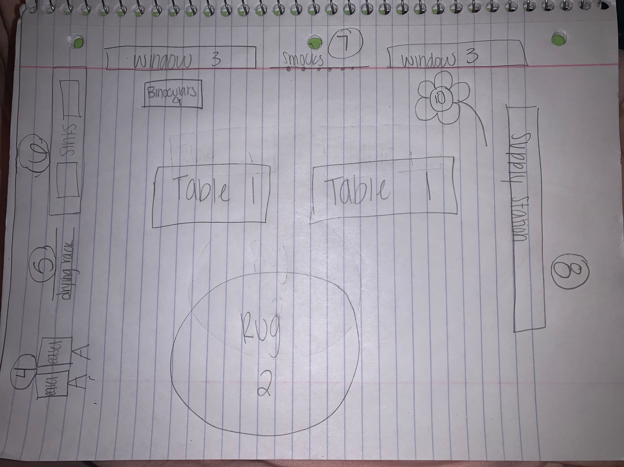
Art center floor plan and center information:

- Tables for the activity they are working on. Students will sit in groups of 6 so they can help each other think about creativity and the stages.
- Rug. This is where students can come together to show off their artwork that they have created at the art center.
- Windows. Each window has a different tool students will be able to use to expand their learning.
- Easels. Students will be able to use easels if they choose to do so to create their drawings. Only one student is to use an easel at a time to think about their creative drawings.
- Drying rack. The drying rack is where students who have used paint will hang up their paintings to dry.
- Sink. The sink is used for students to wash their hands, and to clean off any of the paint brushes they have used.
- Smock. Those who will be painting and do not want to make a mess on their clothes will use the smocks provided for them. The smocks can also be used for any student who want to pretend role play as an artist.
- Supply station. This is where all of the art supplies will be stored. There will be a variety of materials including crayons, pens, markers, paint, brushes, scissors, glue, paper plates, and other items to create art. There will be bins at this station that are labeled what it is holding.
- Binocular. This will be by the window in a box. They will be able to use the binoculars to look outside to see the nature. They can use this tool to get their creative thinking started, and to see how nature looks.
- Flower. This will be a large flower by the other window. Here students can create models of the four-stage life cycle of a butterfly, and place them onto the flower.
Purpose of this center-
The purpose of this center is to get my students thinking creatively, and to show that by creating drawings, paintings, and sculpture about the life cycle of a butterfly. Through the various materials provided, students can choose to express their work. I also want my students to use the other tools provided to spark their curiosity of how we can see art.
Skill I want the students to develop-
I want my students to develop creativity, curiosity, self-expression, and collaboration. Students will be able to develop creativity by showing how they think and making it into a piece of art. They will use their curiosity to spark their thinking of how they want to show their way of thinking. They will be developing self-expression by being able to create the image in their mind into a piece of art, and show the class. Students will also be developing their social skills by collaborating with other their ideas, and helping those around them.
Basic materials needed for the center-
Colorful construction paper, crayons, pens, map pencils, markers, paint, paint brushes, erasers, paper plate, pom poms, toilet paper roll, pipe cleaners, scissors, glue sticks, googly eyes, and a variety of uncooked noodles.
Guidelines-
- The student will be respectful to other classmates art.
- The student will respect the tool and materials that are provided to them
- The student will clean up after each art work they create.
- The student will place all materials back to their original home.
- The student will clean the paint brushes after using them.
- The student will clean up a mess made by paint.
- The student will place their wet paint artwork onto the drying rack.
- The student will not criticize another student’s artwork.
- The student will make sure all caps are placed back onto glue bottles and markers.
Assessment instrument-
The teacher will assess the students about their science knowledge and art knowledge through using the chart provided below. This will help the teacher keep track of each student after the activity to see where information was not given. The chart below will see if the student knows the four stages, and if they are following the directions provided. The teacher will also be asking questions throughout the lesson to see where the student is with their learning.
Points | 3 | 2 | 1
All stages are present of the life cycle. | All 4 stages are present in piece of art work. | 3 stages are present in piece of artwork. | 2 or less stages are present in piece of artwork.
EXTRA POINTS: |  |  | Student shared their artwork with the class.
EXTRA POINTS: |  |  | Student cleaned up art mess, and put away materials properly

